**CHAPTER ONE**

**INTRODUCTION**

This chapter will describe the context in which this investigation was launched, the description of difficulties that led to this study, and the Aim and Objectives of the study as a prologue to subsequent aspects of this study. Others include the significance of the research, the scope of the work, study limitations, and definitions of technical terminologies.

**1.1** **Background of the Study**

Because information development has progressed so quickly at this time, many firms have employed information systems to better their operations. To enhance a company's business, a good information system must be built, and the prerequisite to developing a strong information system is the speed and accuracy with which the information is obtained. In today's world, computers play an important role. Nowadays, we utilize computers to make our jobs easier and save time. Almost all sectors or institutions, such as convenience shops, malls, restaurants, hospitals, and hotels, employ computers for simple and convenient transaction processing. Nonetheless, organizations still employ manual processes since they do not use computers to operate. (Margareta & Pataropura, 2018)

The process of gathering, entering, storing, categorizing, summarizing, and analyzing data is known as record keeping. Financial record keeping and management record keeping are two aspects of record keeping. The primary goal of a financial record is to aid decision-makers in analyzing a company's financial soundness, profitability, and future prospects. Managerial record keeping, on the other hand, is suited to the demands of a certain firm. It assists executives in measuring progress in carrying out their plans, identifying problems that require executive attention, and achieving organizational objectives. (Margareta & Pataropura, 2018)

A sales management system takes data from business activities such as sales statistics, and inventory changes, and then translates the data into analytical reports. The sales management system uses current operational data to provide useful reports such as product and time-specific sales analysis of the cost of keeping inventory before it is required for production. (Margareta & Pataropura, 2018)

**1.2 Statement of the Problem**

The following are some of the study's issues:

1. The recording of sales and money received is done manually on a rough book.
2. It is difficult to predict when specific things must be refilled.
3. The manual inventory approach is both demanding and time-consuming.
4. Human mistake causes inaccuracies in record keeping.

**1.3 Aim and Objective of the Study**

The project is aimed at developing and implementing a sales record management system for Delfak Nigeria Limited.

**Objectives**

The objectives of this research work are as follows:

1. To create a database to aid in the storage of sales records.
2. To ensure account consistency and error minimization due to damage.
3. To automate sales and inventory tasks/activities.

**1.4 Scope of the Study**

This research work will concentrate on Delfak Nigeria Limited employees as they may view and manage sales data from a single dashboard. In this scenario, the system concentrated on daily sales, costs, invoice statements, and the generation of adequate reports. However, because there are severe difficulties with the Company, the system will not be able to run beyond this point, for example, accounting information such as income statements, balance sheets, and trial balances, among others.

**1.5 Limitations of the Study**

Some of the limitations that may have influenced the conclusion of this research include:

**Time** - Due to the school academic calendar, the time window allocated to complete this project was quite short, and it was carried out under pressure, causing the researcher to fail to include several required elements.

**Finance** - The requirement for a typical functional personal computer unit to execute and debug the application software hampered the task's quick and simple progress

**Power:** The lack of a steady, efficient, and dependable power source was another key constraint for this project, as it suspended the work multiple times during the design and testing stages.

**1.6 Significance of the Study**

The importance of this study is to Delfak Nigeria Limited, which would give an easy-to-use and easily accessible system, allowing transactions to be more reliable and faster, eliminating the need to pay another company to complete the task. It provides more accurate and secure sales and product list records. It will aid in a variety of ways in easing the queue process at supermarkets. This will also aid in the maintaining of correct records. The study will be particularly relevant to the following:

1. Admin: is in charge of adding stocks, maintaining inventory, and deciding system users.
2. Customers benefit from printed receipts immediately after purchasing an item.

**1.7 Project Organization**

For ease of study and proper understanding of this project write-up, it is planned and organized into five chapters. The description of what each chapter contains is explained below:

**Chapter One: Introduction**

Chapter one contains an introduction to the write-up, the problem statement of the study, the aims and objectives of the study, the significance of the study, the scope and limitation of the study, and the organization of the report.

**Chapter Two: Literature review**

This chapter contains the literature review of the study, an overview of the proposed system, and the contribution of other scholars on the subject matter being discussed.

**Chapter Three: Methodology and Design**

This chapter presents the research methodology used in the development of the system to facilitate an understanding and effective future implementation of the system and also the presentation of the results of system analysis and design.

**Chapter Four: System Implementation Evaluation**

The Chapter contains system design implementation and documentation, design of the system, output design, input design, and system requirements for implementation.

**Chapter Five: Summary, Conclusion, and** **Recommendation**

The chapter provides a summary of major findings, conclusions, and recommendations based on the study conducted.

**1.8 Definition of Terms**

1. **Automation:** This is the use of a control system, such as a computer, to control and process data, therefore eliminating the need for human interaction**.**
2. **Computerized:** To begin utilizing a computer system to govern, organize, and automate anything that was previously based on a based system**.**
3. **Record System:** The act of employing a computer system to systematically store and update information in order to maintain file security**.**
4. **System:** A collection of computer components (that is, the assembling of hardware, software, and peripherals to function together).
5. **Inventory:** This is the items and supplies that a company keeps for the purpose of reselling.
6. **Sales:** These are transactions in which commodities or services are exchanged for money.

**CHAPTER TWO**

**Literature Review**

**2.1 Introduction**

This chapter seeks to explain how the topic under research relates to prior research, current practice, or other areas of knowledge by citing relevant works by other scholars that have addressed a related issue. Furthermore, this chapter will present a synthesis of current research on the topic, highlighting areas of agreement, disagreement, and gaps in the literature, to demonstrate the project topic's relevance in the field and to recommend opportunities for future research.

**2.2 Literature Review**

Margareta and Pataropura (2018). Design And Development of Sales E-Monitoring Information System. Pratama Inti Distribusindo still does not utilize a computerized system to monitor operations in its firm; instead, the monitoring is done manually, resulting in delayed performance of staff in processing data, both transaction data and associated papers in the company's sales. Aside from that, it takes a long time. To locate the data required to create reports required by the leadership since the data is kept manually rather than electronically.

Finally, the following conclusions may be derived from the process of developing a sales monitoring system:

1. This application can aid in the control and monitoring of the process of meeting salesperson objectives.
2. This program may assist each division in creating the report, making it more effective and precise.
3. Using this application, each division may obtain commodities data, customer data, salesman data, target salespeople, and salesman sales directly as required.

Lubwama (2017). Sales Management Information System. Despite modern information technology trends, Nawab Asian Bistro Restaurant continues to use traditional data processing methods such as filing files in cabinets and drawers, manually entering sales and stock in books, which is subject to fraud, data loss, and human error. It is difficult to troubleshoot or test, unable of creating appropriate reports, data redundancy of sales records, and paper files take a lot of office space, perhaps resulting in corporate loss.

Moreso, the system was built on the concepts of a relational database management system, with all of the advantages that come with it over alternative database management systems. SQL application supported the system's back end and was combined with PHP programming. PHP is capable of interacting with a wide range of database systems that use an open database connectivity standard (ODBC), such as. MySQL, Oracle, Microsoft products, and others. Low cost and availability are further advantages. PHP is a cross-platform programming language that was developed as an open-source project.

In conclusion, based on the study's objectives, it was determined that sales tracking management for restaurant sales has a significant influence on decision making. The restaurant's service delivery has generally declined due to ineffective methods of handling sales data.

Shabani et al. (2021). Inventory Record Inaccuracy and Store-Level Performance. The impacts of IRI on retail shop inventory and sales management performance are examined in this article. We present a unique network data envelopment analysis (NDEA) model that can determine store-level performance criteria more precisely than existing methods. The insights of the proposed NDEA model are utilized to produce two unique performance indicators: the IRI improvement potential and the IRI improvement burden, to assist managers in identifying the core causes of IRI and establishing realistic targets for minimizing IRI.

Furthermore, this study makes use of real-world data from an international fashion shop. The data collection includes information on over 5,250,000 inventory items stored in 81 retail shops. The computer studies demonstrate the advantage of utilizing relative measures to precisely assess IRI levels across SKUs.

In conclusion, breaking down store-level management into inventory management and sales management has been proven to be quite useful for assessing the influence of IRI on store-level performance. Furthermore, numerical studies show that IRI improvement is moderate for near-efficient stores but strikingly great for extremely inefficient businesses.

Laar et al (2017) in his work titled “Design and implementation of Sales management system for SMEs in Ghana” he stated that in common use, most business owners think of sales management as a purely accounting process. This conflicts with the definition of sales management as “the attainment of sales force goals in an effective and efficient manner through planning, staffing, training, leading and controlling organizational resources. Sales management is also defined by the American Marketing Association (AMA) as “the planning, direction and control of personal selling, including recruiting, selecting, equipping, assigning, routing, supervising, paying and motivating as these tasks apply to the personnel sales force”. Thus it is clear that sales management is not purely an accounting function. However, it links with accounting in the area of record keeping as accounting is employed to interpret data from sales operations. A sales management system (SMS) can thus be thought of as the mechanism used by sales managers to make sales management easier and faster. It has been defined as an “Information System used by sales professionals or business entities for sales tracking which facilitates the sales management process”. A working sales system comprises a point of sales system (POS) at the front end and a detailed implementation of various sales management and tracking functionalities at the back end. This structure directly mimics the sales process in a sales environment where the sales agents are at the front end interacting directly with customers whiles managers handle the reports from the transactions.

Varalakshmi and Shivaleel (2021). A Review of Inventory Management System. Inventory is a critical component of the Inventory Management System that must be well-managed in order for everyday company activities to function smoothly. Some organizations, however, may not understand the need of inventory management since they do not have a computerized system to operate their business. As a result, the degree of security for all data, papers, and anything else related to daily transactions and inventories is exceedingly poor. A significant amount of papers and data have been retained for each good and each supplier, which takes a long time and is ineffective for future references, creating time-consuming.

Moreso, the major approach employed in this study was an investigation of shopkeepers. This study is based on both direct data from store owners and secondary data from journals, books, articles, annual reports, and websites. The methodologies used in this study include safety stock inventory, FIFO, and LIFO.

In conclusion, the article describes an Inventory Management System that saves sales data for a specific desktop application. It's a basic desktop program that connects to the real distribution center, allowing information to be refreshed and validated in the shop. It's a safe program that keeps data safe in storage. It also gives sales data on a daily, weekly, and monthly basis. This method makes inventory management a snap. The inventory management system will result in increased income and profitability, a better working environment, and an overall increase in customer happiness.

**2.3 Summary of Related Literature Reviews**

|  |  |  |
| --- | --- | --- |
| **Author & Year** | **Title & Description** | **Merit and Demerits** |
| Margareta and Pataropura (2018). | Design And Development of Sales E-Monitoring Information System.    The study focuses on developing a sales monitoring system at PT. Pratama Inti Distribusindo, which will provide sales system  solutions at PT. | The system aided in the generation and verification of reports.  Strictly limited to the web. |
| Lubwama (2017). | Sales Management Information System  The system is customized for the use by Nawab Asian Bistro's workers to access and manage sales data through a single dashboard. | The system has a great impact to decision making in the restaurant  The study scope is limited to just one department of the restaurant. |
| Shabani et al. (2021). | Inventory Record Inaccuracy and Store-Level Performance.  This article examines the effects of IRI on retail shop inventory and sales management performance. | Numerical studies show that IRI improvement is moderate for near-efficient stores.  Numerical studies show that IRI is strikingly great for extremely inefficient businesses. |
| Varalakshmi and Shivaleel (2021). | A Review of Inventory Management Systems  This article describes an Inventory Management System that saves sales data for a specific desktop application | It also gives sales data on a daily, weekly, and monthly basis.  The application is limited to just desktop users. |

**2.4** **Operation of the Existing System**

Like many other conventional systems Delfak Nigeria Limited currently operates manually in making sales and the cost of expenses incurred in production which has often led to fraud and lack of proper information on sales and expenses in order to enhance decision making

**2.5 Problems of the Existing System**

In the manual processing of sales in Delfak Nigeria Limited, a lot of difficulties are encountered. Below are some of the difficulties:

1. Fatigue
2. Time consuming in calculating total expenses incurred in production.
3. Generating report of sales and expenses

**2.6 Benefits of the New System**

### The propose system sales record management system for Kaduna Polytechnic Bakery, will provide accurate and efficient sales and expenses report. Unlike the manual process, the computerized method does not require much work and information retrieval is fast. The system further provides a number of benefits which include

### Efficiency: The office staff can easily search for sales report daily monthly and annually respectively which time is saving and brings efficiency in operations.

* + - 1. **Enhance Decision Making:** the propose system will provide adequate information that will enhance decision making in the organization.

**CHAPTER THREE**

**Methodology and Design**

**3.1 Introduction**

A methodology is a rigorous study or inquiry, particularly to unearth new facts or information; thus, research methodology should be good enough to enable the achievement of the specified objectives, which are achievable using specific components, such as data collection and design procedures, and system modeling (use case, activity, and class diagrams). This chapter provides the input/output specifications as well as the system requirements for a sales record management system.

**3.2 Methods of Data Collection**

Before developing any system, collecting data and facts about the existing system is critical to understand what is going on. This research was carried out using three methods.

1. Observation of the Work Environment
2. Interview
3. Documentation

**3.2.1 Observation of the Work Environment**

By observing how the manual system worked, this strategy was used to collect information and data for this study. A thorough examination revealed the most obvious flaws in the current system. When using the observational technique, the environment in which the observation is made can be changed in a variety of ways.

**3.2.2 Documentation**

Secondary data gathering includes documentation. Journals, manuals, previous work, publications, and other sources are used in this manner. This data-gathering strategy is chosen because it allows for comparison with previous research. This includes the internet, which is a tool for data collecting. The internet was utilized to research complex or unclear problems.

**3.3 System Modeling**

A system model is a conceptual model of a system that explains and represents it. A system is any interaction between a set of components that work together to achieve a common purpose. Visual models of object-oriented software-intensive systems may be created utilizing a set of visual notation techniques included in the Unified Modeling Language, which is used in the creation of this contemporary system. UML diagrams utilized in this new design include use case diagrams, class diagrams, and activity diagrams.

**3.3.1 Use Case Diagrams**

Use cases are collections of interactions between the system and the user. Use case diagrams are used to graphically depict a system's functionality in terms of its actors, goals (represented as use cases), and dependencies among those use cases.

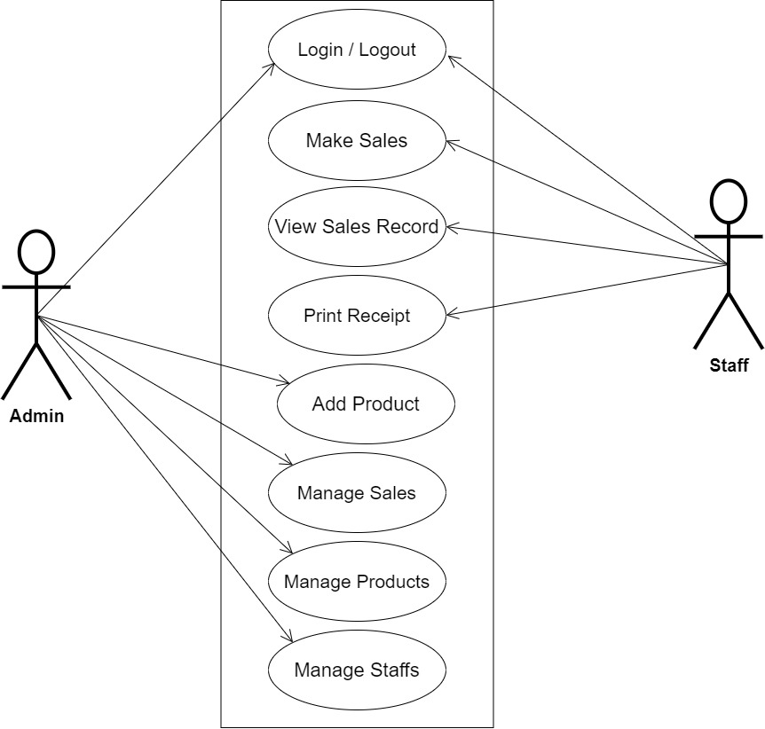

**Fig 3.1 System Use Case Diagram**

**3.3.2 Class Diagrams**

The Unified Modeling Language (UML) class diagram represents an independent opinion of how the system interface might appear, with each class having its own set of characteristics and displaying how they interact with one another. Class diagrams use the Unified Modeling Language (UML) standards to visually depict a system's static structure and composition.

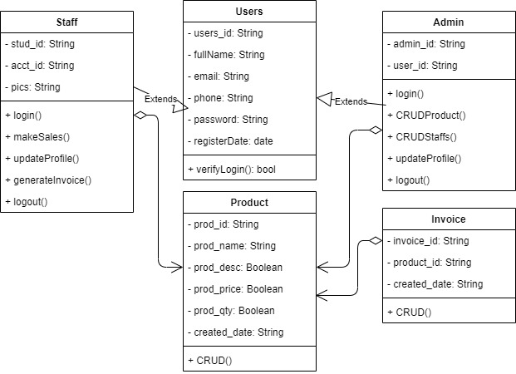

**Fig 3.2 System Class Diagram**

**3.3.3 Activity Diagrams**

An activity diagram, like a flowchart or a data flow diagram, visually illustrates a series of events or the flow of control in a system, but it acts more like an enhanced version of both.

**Login**

The process for gaining access to the system is depicted in the diagram below; the email address and password must be accurate to gain access.

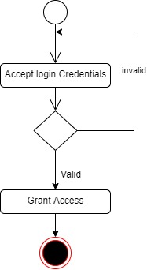

**Fig 3.3 Login Activity Diagram**

**Make Sales**

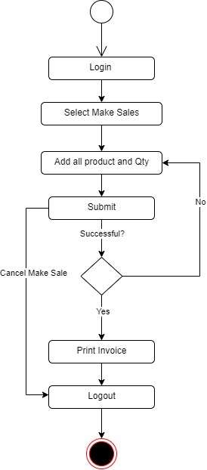The process making sales by a staff is depicted below, to view the staff has to be authenticated.

**Fig 3.4 Make Sales Activity Diagram**

**3.4 Database Design**

The logical explanation of how data is kept in the computer's memory is called input specification. The freedom experienced in using the system, as well as the convenience of retrieving and reading the data and assuring applicability across the internet, make SQL standards essential for ensuring that structured data is uniform and independent of applications. Some of the input specifications employed in this project work are presented below.

1. Users Table: contains basic information about all system users.
2. Product Table: contains every system-saved student product information.

**Table 3.1 Users** **Input Specification Table**

|  |  |  |  |  |  |
| --- | --- | --- | --- | --- | --- |
| **Field Name** | **Data Type** | **Null** | **Key** | **Length** | **Description** |
| user_id | Varchar | No | PK | 32 | Unique string for identifying invigilators |
| email | Varchar | No |  | 100 | User email address |
| password | Varchar | No |  | 128 | User Password |
| fullName | Varchar | No |  | 60 | User full name |
| phone | Varchar | No |  | 11 | User phone |
| Register_date | DateTime | No |  | 20 | User registration date |

**Table 3.2 Product** **Input Specification Table**

|  |  |  |  |  |  |
| --- | --- | --- | --- | --- | --- |
| **Field Name** | **Data Type** | **Null** | **Key** | **Length** | **Description** |
| prod_id | Varchar | No | PK | 32 | Unique string for identifying products |
| prod_name | Varchar | No |  | 100 | Product Title |
| prod_desc | Varchar | No |  | 100 | Product Description |
| prod_price | Varchar | No |  | 128 | Product Price |
| prod_qty | Varchar | No |  | 10 | Product Quantity |
| created_date | DateTime | No |  | 20 | Date the clearance was initiated |

**3.5 Output Design**

This declares and displays the outcome of the given input. This Computerized system's output is dependent on its input. The output specification is listed below.

**Table 3.3 Users** **output design table**

|  |  |  |  |  |  |
| --- | --- | --- | --- | --- | --- |
| **User_id** | **Email** | **Password** | **FullName** | **Phone** | **registerDate** |
| XXXX | XXXX | XXXX | XXXX | XXXX | XXXX |
| XXXX | XXXX | XXXX | XXXX | XXXX | XXXX |
| XXXX | XXXX | XXXX | XXXX | XXXX | XXXX |
| XXXX | XXXX | XXXX | XXXX | XXXX | XXXX |

**Table 3.4 Product** **output design table**

|  |  |  |  |  |  |
| --- | --- | --- | --- | --- | --- |
| **Prod_id** | **Prod_name** | **Prod_desc** | **Prod_price** | **Prod_qty** | **Created_date** |
| XXXX | XXXX | XXXX | XXXX | XXXX | XXXX |
| XXXX | XXXX | XXXX | XXXX | XXXX | XXXX |
| XXXX | XXXX | XXXX | XXXX | XXXX | XXXX |
| XXXX | XXXX | XXXX | XXXX | XXXX | XXXX |

**3.6 Input & User Interface Design**

This is a graphic depiction of the system interface; it will be designed to be user-friendly, responsive, and visually beautiful. Furthermore, it will be fully secured, thus authentication will be required to see various levels of the information. To help with the designs, a mid-fidelity wireframing program called Draw.io is employed.

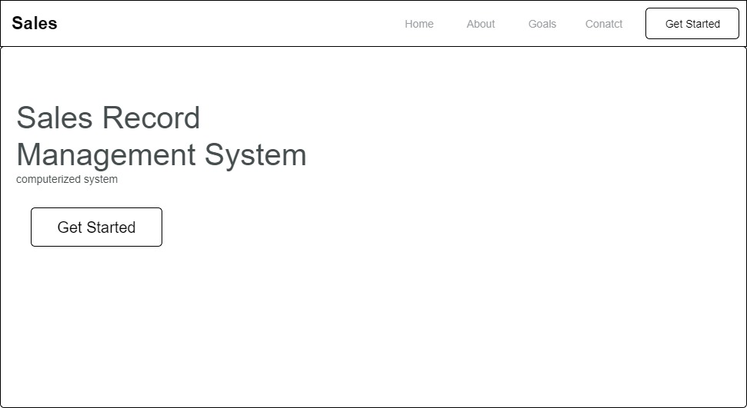

**Fig 3.6.1 Home Page**

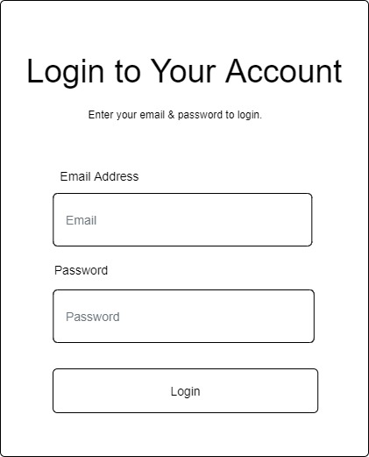

**Fig 3.6 User Login Form**

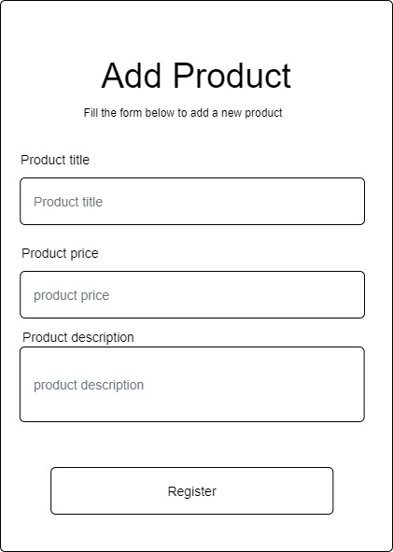

**Fig 3.7 Add Product Page**

**3.7 System Requirement**

Every piece of software that is generated has predefined system requirements that it must fulfill to function properly. The system requirements, on the other hand, are the bare minimum of hardware and software required for the system's intended operation.

**3.7.1 Hardware Requirement**

System Hardware Requirement Include:

1. Minimum of 8 GB of RAM (Random Access Memory) installed.
2. Minimum of intel core i3 processor.
3. Minimum of 250GB HDD (Hard Disk Drive).

**3.7.2 Software Requirement**

The software requirements include:

1. At least windows 7 OS (Operating System).
2. Python Installation.
3. Vs. Code installation.
4. Browsers include Chrome and Firefox.

**3.8 Choice of Programming Language**

This research work will be a web-based application and will be implemented on a relational database system (MySQL). HTML (hypertext markup language), CSS (cascading style sheet), and JavaScript will be employed in the front end while PHP will be employed for the backend programming. The above are the modern languages used in implementing this system.

**CHAPTER FOUR**

**System Implementation Evaluation**

**4.1 Introduction**

This chapter discusses a concise detail on how the system is to be implemented and sample of the working procedures of the proposed system. The chapter entails the program listing; sample outputs obtained during the design and implementation of a sales record management system for Delfak Nigeria Limited as well as Installation procedure for purpose of guiding new user on how to use the new System and also system testing changeovers.

**4.2 System Testing and Evaluation**

Testing is considered as an important part of a system life-cycle. Because, after implementing the testing of the new system, we can ensure that the new system made it require functionality and free of errors. There are many reasons to conduct the testing for the developed system, because is only through testing that we can be able to analyze any problem in the new system and provide solutions to these problems This project employed both Unit and Integral test to ensure effectiveness and efficiency of design of information system.

**Unit Testing**

In this phase, individual units or single components of the system are tested independently to ensure that individual phases are working effectively without errors.

**Integration Testing**

In this phase, all the various components of the system are tested together using the actual data which will be submitted to the management for approval/acceptance.

**4.3 System Installation**

After the system has been tested for some period of time, and found to be working smoothly as expected, the system will be ready for Installation and Implementation. For the new system install successful the following requirement are needed: this is how to install the system

1. Make sure, pip, pipenv and Python3 or greater is installed on the system.
2. Copy your project folder to any location of your choice.
3. Open project folder in Visual Studio Code
4. On the terminal run “pipenv install -r requirements.txt”
5. On the terminal run “python manage.py runserver”
6. Open any browser on the system example Chrome, Microsoft Edge, Mozilla Firefox
7. On the address bar, type <http://127.0.0.1> and press the enter key.

**4.3 System Conversion Plan**

In preparation for the installation of a new system, the method of changeover to be adopted would have to be given serious consideration as whatever methods adopted would some extent determine the success of the new system. Possible conversion are direct, parallel and pilot methods. But the type of changeover I used during the implementation of this new system is parallel conversion.

**Parallel Converson:** It requires the ruling of both the new and current system side by side until the integrity of the new system has been proved beyond reasonable doubt; the current system is completely discarded. This is accomplished by comparing the result produced by the current with that of the new system. Although, this parallel changeover method is quite expensive, it is the best of all conversion methods as it guarantees a safe and efficient new system. Moreover, the time of paying double change is quite short enough and worth the trouble. This method of conversion is therefore highly recommended suitable for this new system.

**Why parallel Conversion:** it’s expensive but it guarantees an efficient and successful new system. Moreover, it helps in identifying common errors which the new system could not be able to overcome.

The administrators would be convenient in working with the two especially if they are not conversant with computer system. If the automated system is well understood by the administrators and also being able to meet the design objectives then the manual system can be completely withdrawn.

**4.5 Security Measures**

Since the scope of the website is public, some of the information such as index page, login page e.t.c are available to anyone who visits the website. But some other information and functionalities are restricted to some and not all who visit the website. The restrictions are carried out by the use of passwords which gives different level of access to users. The highest level of access is held by the admin, followed by the staffs with lesser access.

**4.6 Program Sample Outputs**

These describe and give the pictorial representation of the program or software; it shows and gives clear understanding of the design, and displays all the interfaces.

**4.6.1 Homepage**

This is the program homepage.



Fig 4.6.1: Homepage

**4.6.2 User Login**

This is a page that grants users (admin / staff) access to the system only if correct credentials are provided.

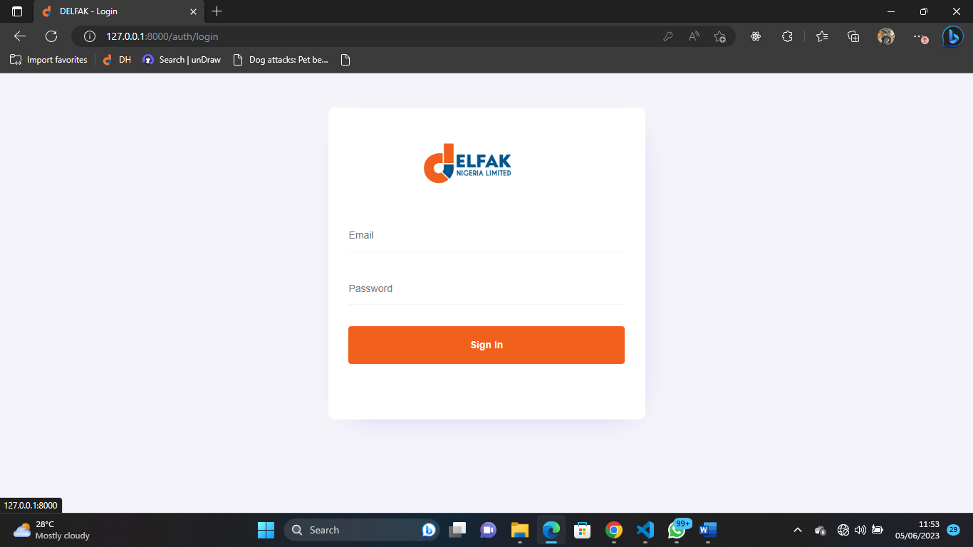

Fig 4.6.2: User Login

**4.6.3 Staff Dashboard**

This is the staff homepage where staff have access to his or her dashboard.

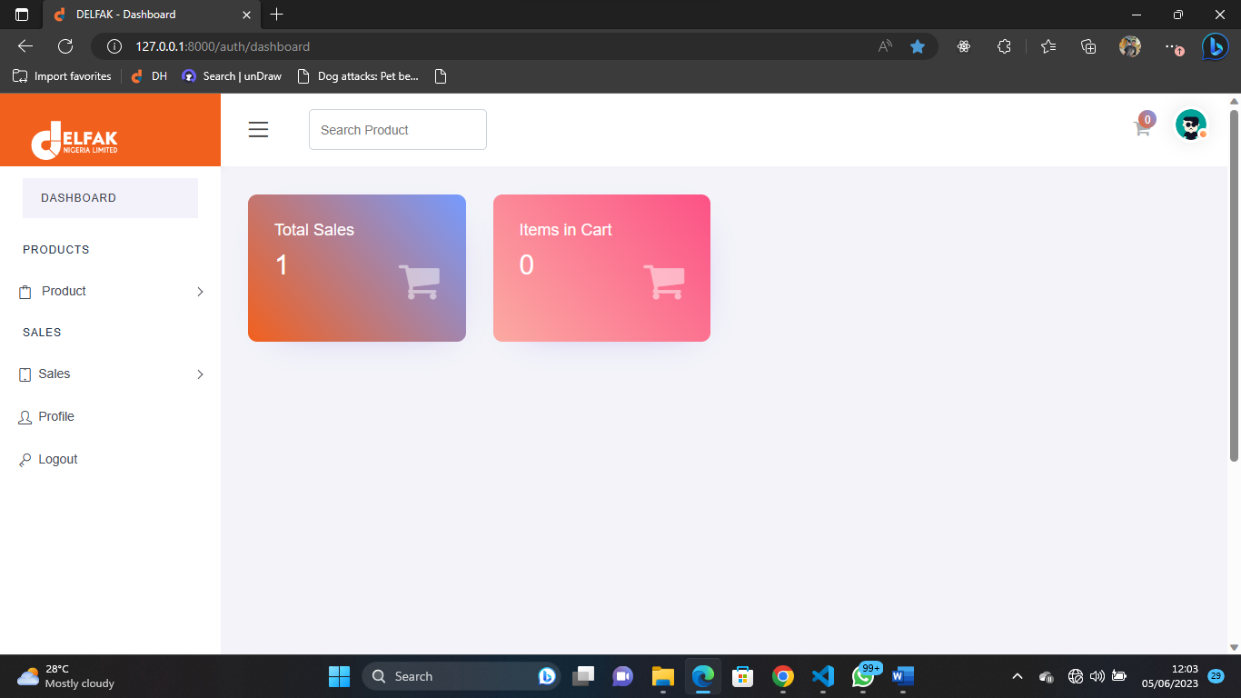

Fig 4.6.3: Staff Dashboard

**4.6.4 Available Construction Materials**

This is the page where staff will have access to make sales of the construction materials for customers

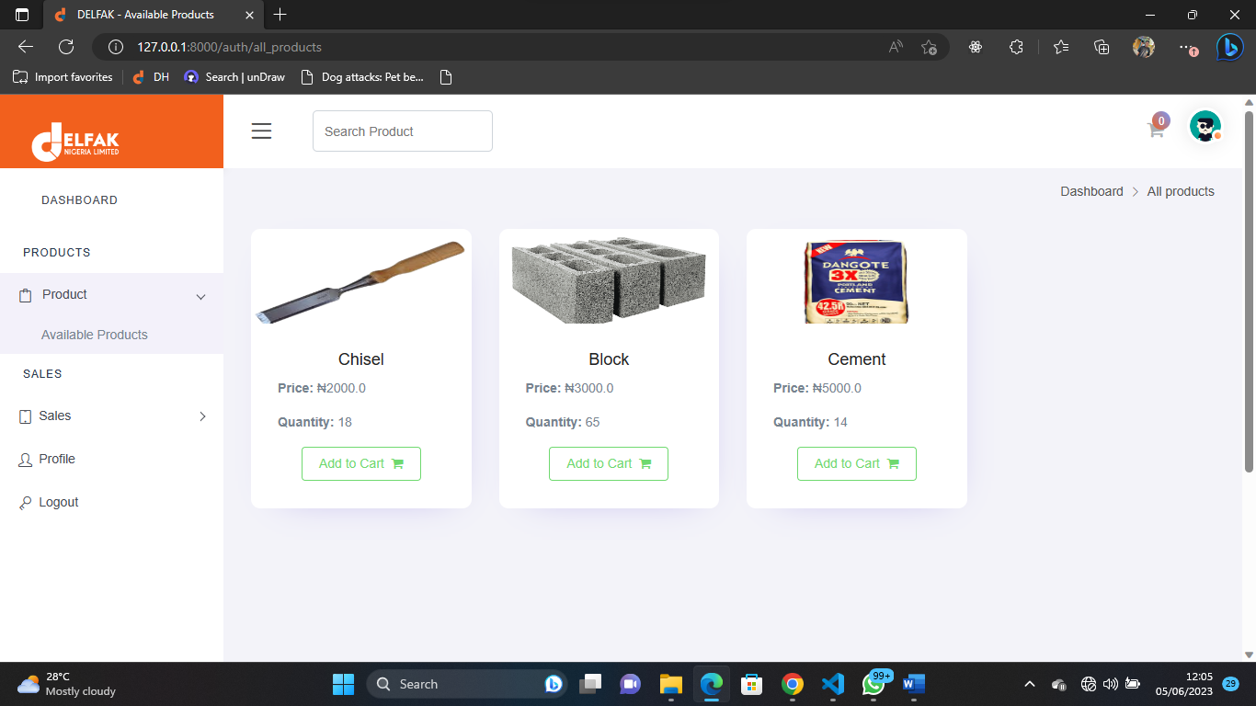

Fig 4.6.4: Available Building Materials

**4.6.5 Items in Cart**

This is when the staff can view the customer items in the cart and decide to complete sale

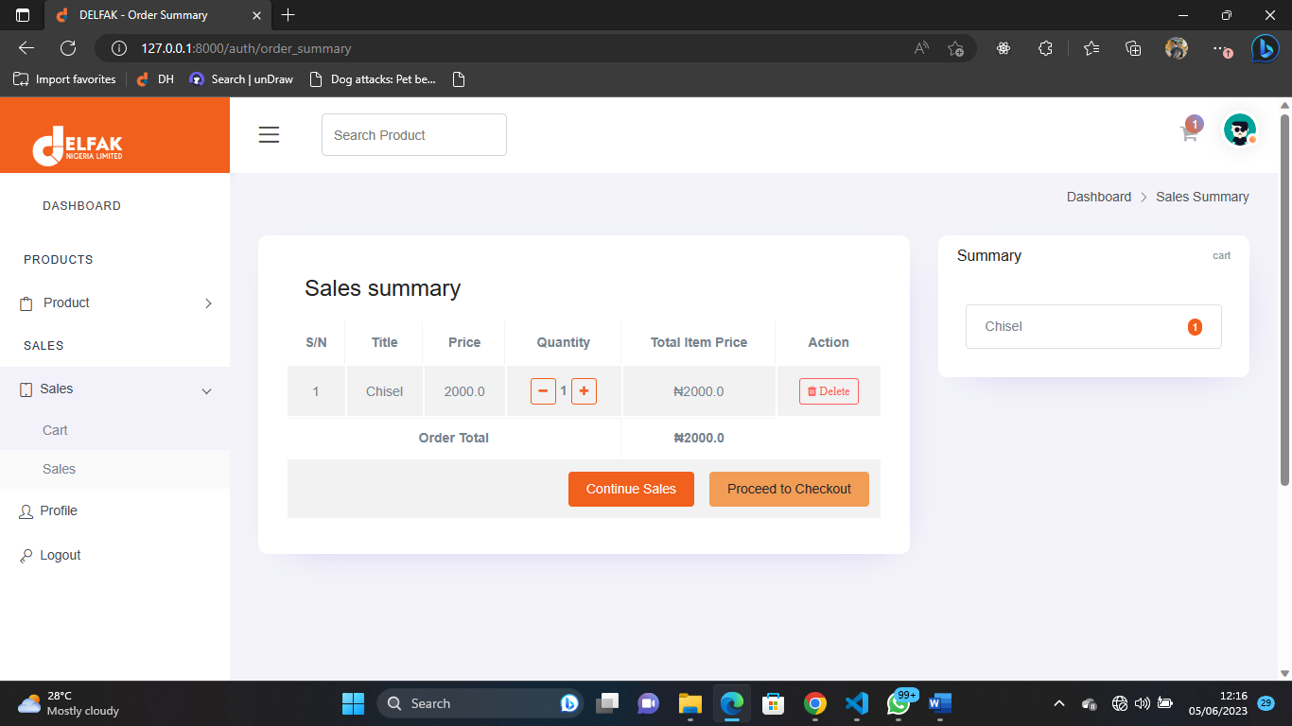

Fig 4.6.5: Items in Cart

**4.6.6 Customer Checkout Form**

This is where the staff can complete the customer sales by entering the customer correct credentials.

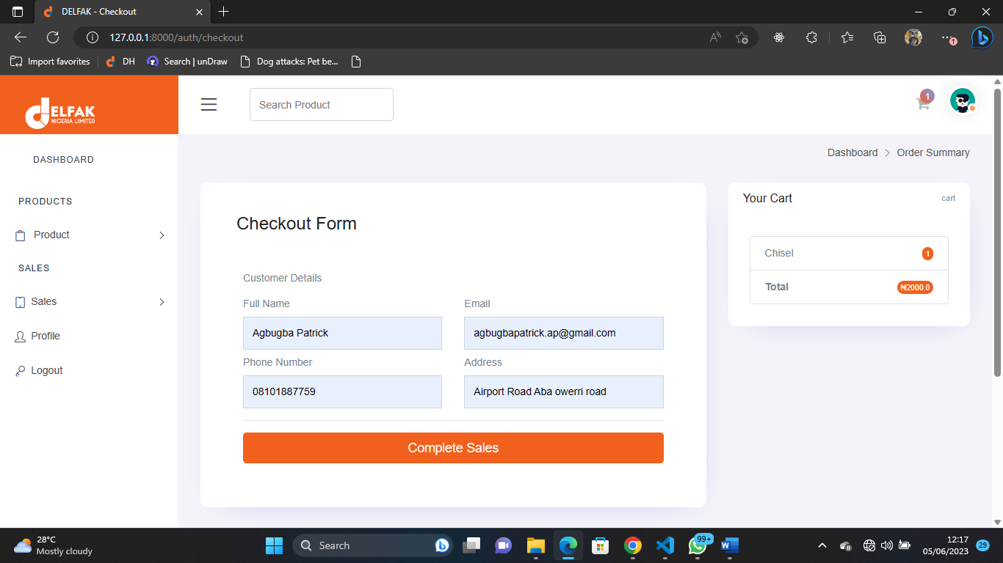

Fig 4.6.6 Customer Checkout Form

**4.6.7 Staff Sales**

This is where the staff can view all the sales that he/she has made.

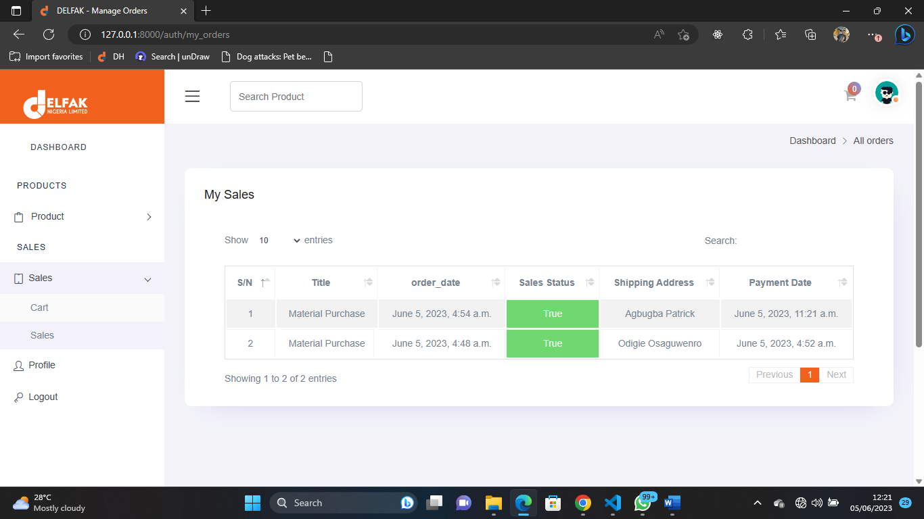

Fig 4.6.7: Staff Sales

**4.6.8 Staff Profile Page**

This is where the staff can view, and change any of his or her profile information.

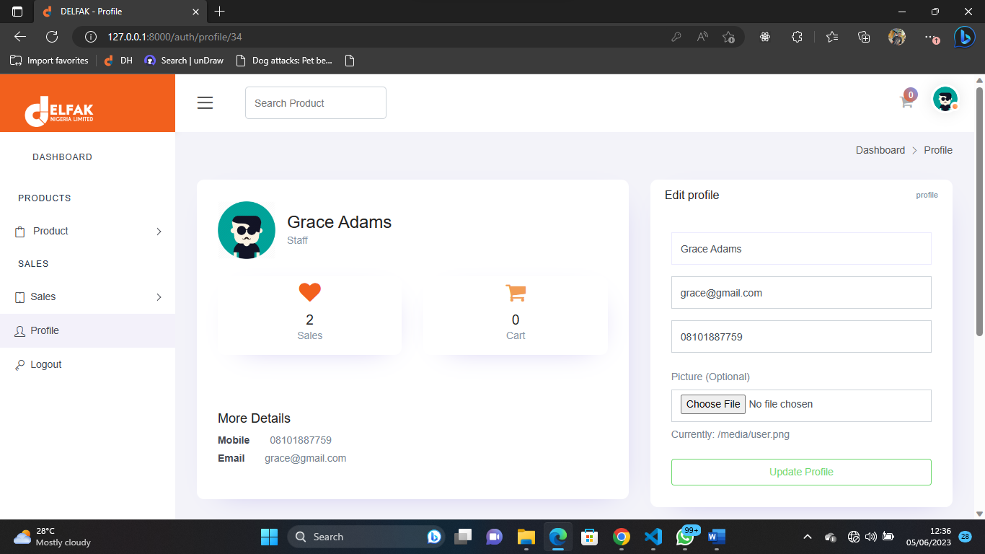

4.6.8 Staff Profile Page

**4.6.9 Payment Receipt**

This is the payment receipt received when staff completes the sales for the customer.

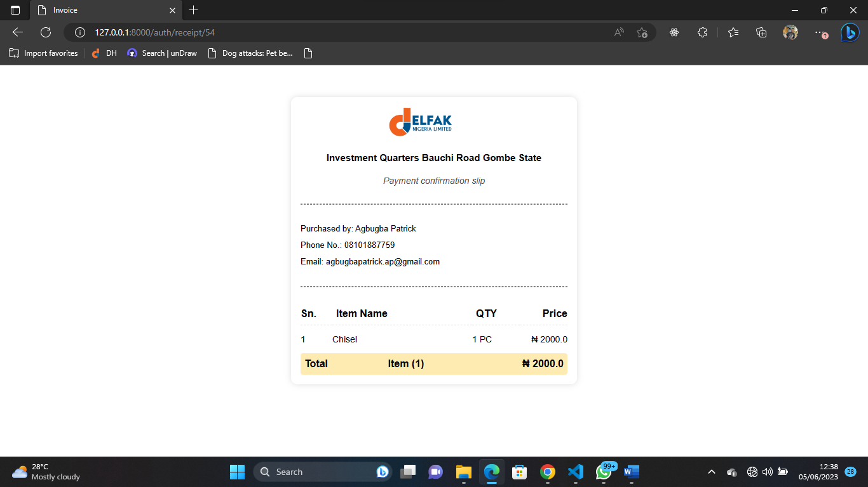

4.6.9 Payment Receipt

**4.6.9.1 Admin Dashboard**

This is the admin homepage where admin have access to his or her dashboard.

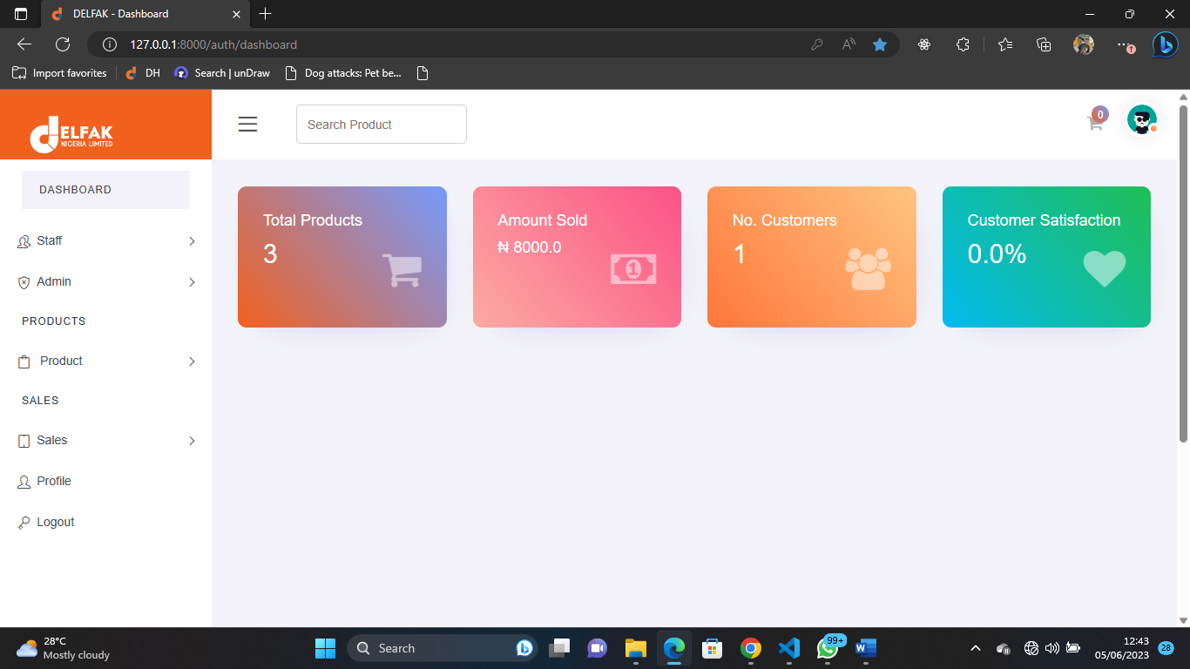

4.6.9.1 Admin Dashboard

**4.6.9.2 Staff Registration**

This is where the admin can create an account for an organization staff, by providing the staff correct credentials.

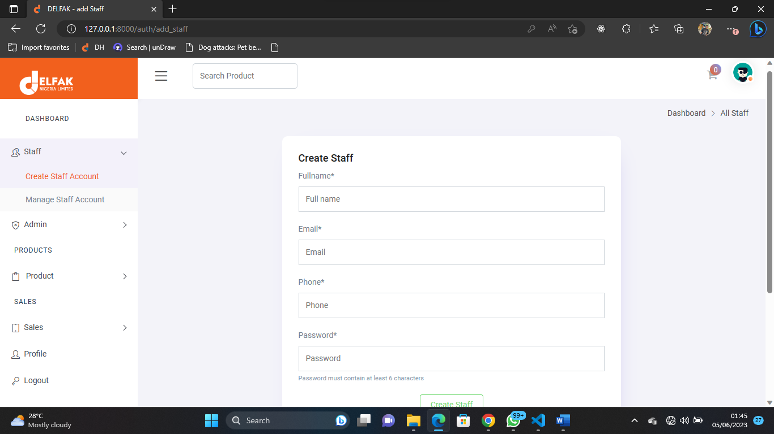

4.6.9.2 Staff Registration

**4.6.9.3 Manage Staff Account**

This is the page where admin manages all the staff accounts.

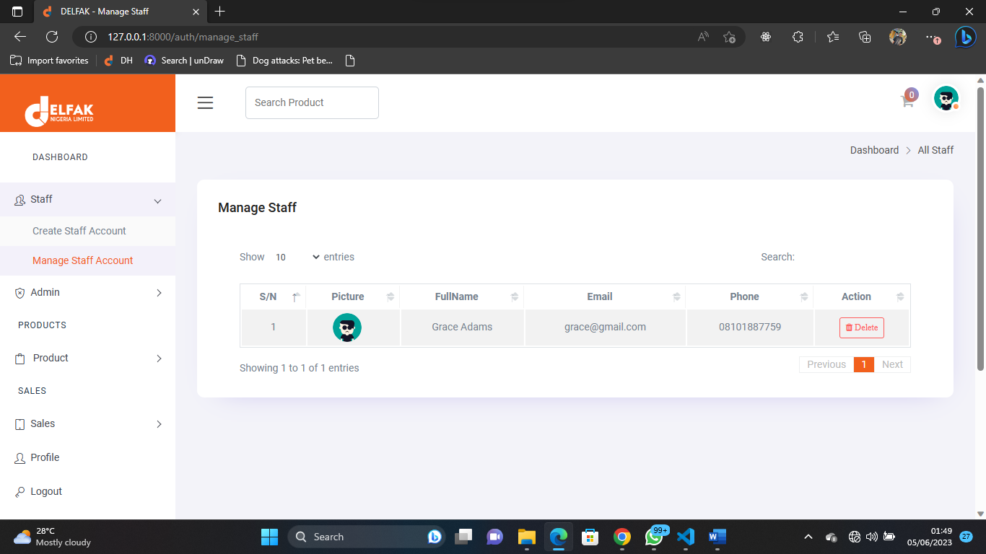

4.6.9.3 Manage Staff Account

**4.6.9.4 Add Construction Materials**

This is where the admin can add new available construction materials.

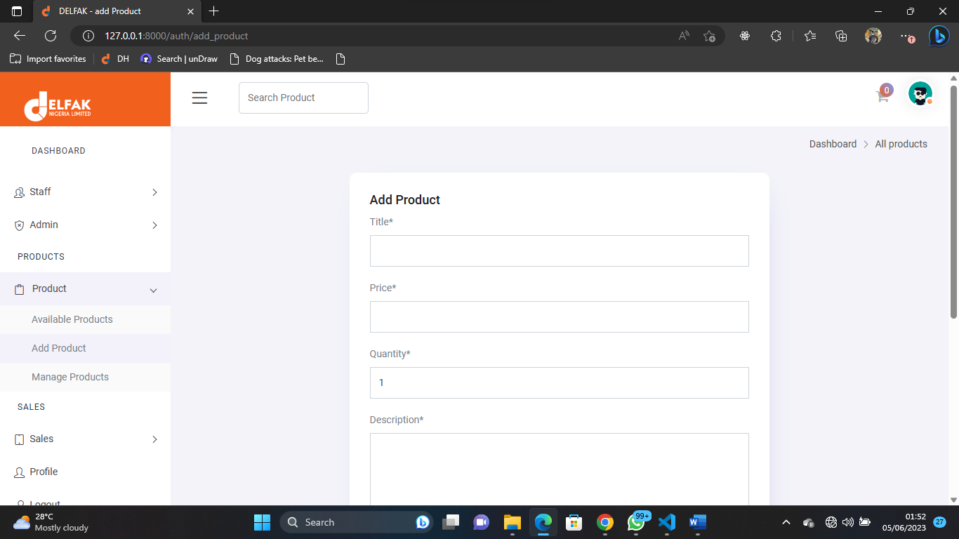

4.6.9.4 Add Construction Materials

**4.6.9.5 Manage Construction Material**

This is the page where admin manages the available products.

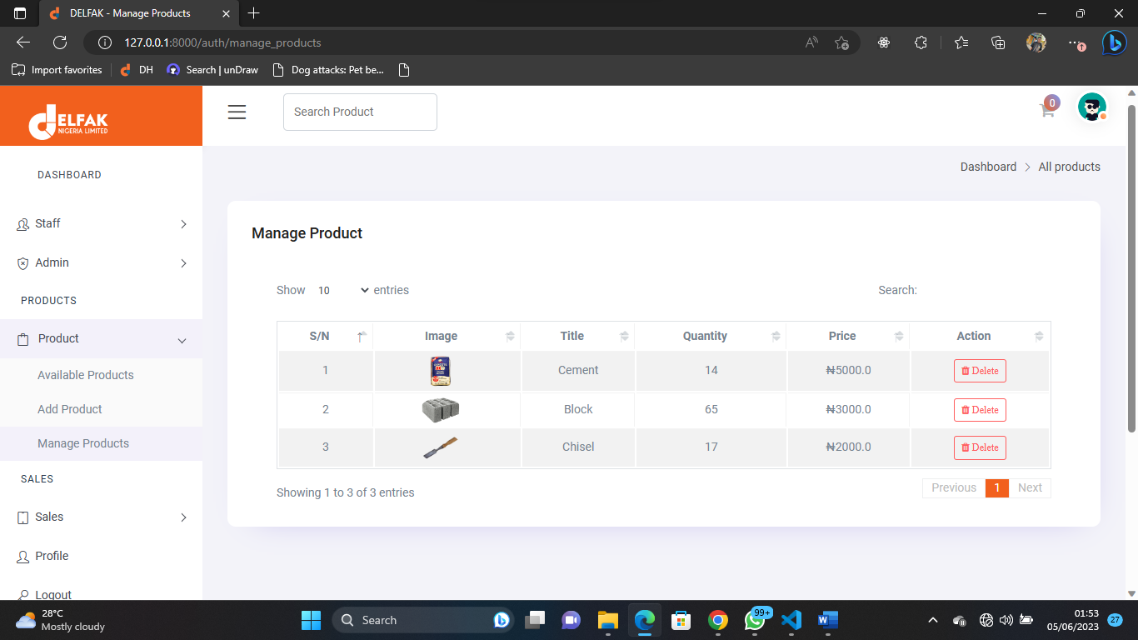

4.6.9.5 Manage Construction Material

**CHAPTER FIVE**

**Summary, Conclusion and Recommendation**

**5.1 Summary**

This project was design to solve a problem that exist in the manual sales record and inventory of Delfak Nigeria Limited construction materials and also serve as a replacement for the outdated manual system used in an organization. The project was a success and the set-out goals of the project was achieved and we were able to design a new system that can keep report/record and also print out payment invoice. The new features are to enhance the capacity of managing and record keeping of the activities of the organization and its staff.

**5.2 Conclusion**

The project was conducted successfully and the purposed of the new system was also achieved. The new system is an improvement compared with to the existing system. The new system is user friendly and it has new features that will be helpful to the organization

**5.3 Recommendation**

Afterward, the following suggestions are recommended:

1. It is recommended that a mobile application should be developed in the near future.
2. When the goods are out of stock the system should be able to alert the admin via SMS.
3. Special backup system should be added to the system.

**5.4 Suggestion for further Studies**

The researcher after being limited to the scope of the study as a result of certain constraints therefore suggests to future researchers to work on similar area as recommended.

**REFERENCE**

Margareta, N.L., & Pataropura, A. (2018). Design And Development Of Sales E-Monitoring

Information System Case Study : PT. Pratama Inti Distribusindo. bit-Tech.

Lubwama S. (2017). Sales Management Information System: *Business Computing Of Ndejje*

*University*

Shabani, A., Maroti, G., de Leeuw, S., & Dullaert, W. (2021). Inventory record inaccuracy and

store-level performance. International Journal of Production Economics, 235. https://doi.org/10.1016/j.ijpe.2021.108111

Varalakshmi and Shivaleel (2021). A Review of Inventory Management System. *International*

*Journal of Advanced Research in Computer and Communication Engineering 10*(6) https://doi.org/10.17148/IJARCCE.2021.10689